Boehly Center Recognition Program Guide

GETTING STARTED

Navigate to the application

STEP 1

In your browser: https://apps.powerapps.com/play/5195c8c9-5a58-46fa-bd18-53d57ce196bc?tenantId=b93cbc3e-661d-4058-8693-a897b924b8d7

In PowerApps mobile app: https://apps.apple.com/us/app/power-apps/id1047318566
STEP 2
Sign Student Expectations/Memorandum
of Understanding (MOU)
Select “Clicking Here” on the Home Page to be directed to the
Student Expectations/MOU. You must complete this form each year prior to receiving points. This is an ANNUAL agreement.

STEP 3
Complete your Student Profile
Complete all applicable fields on all 8 pages. Be sure to save your Student Information along the way. This profile can be updated at any time. Please update your employment information annually.

EARNING POINTS

Select Event/Activity you plan to complete

STEP 4

Each event has a listed number of points that you will receive at the completion and verification of the event. Events may be completed multiple times and you will receive points for each completion.

Every event also has unique “Student Sign-off Requirements.” These requirements must be completed to receive points for the event.
To add an event to your Event Journal, select the event – it will be highlighted in green – and click the plus button again.

STEP 5
Sign-Off Events

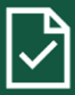
Once the detailed “Student Sign-off Requirements” are completed for an event, navigate to the Event Sign-Off Page to “sign-off” that specific Event.

After you have “signed-off” an event by clicking the check mark, it will disappear from this page but will remain in your Event Journal. The Boehly Center staff will then complete the “Program Sign-off Requirements” and award the earned points.

Review your Event Journal

STEP 6

You can review selected and completed Boehly Events at the top portion of the screen using the scroll bar. You can also delete the Event using the trash icon if necessary.

STEP 7
Make an Advising Appointment

Use the My Advising page to view all your previous advising appointments and appointment details.

Select the advising button on the left to schedule an Advising Appointment. When redirected to the Boehly Center website, select the “Schedule an Advising Appointment” button and complete all applicable fields.

You may reschedule the appointment by navigating to the confirmation email sent after making an appointment. Click “Reschedule” and adjust any information as needed.
You may cancel the appointment by navigating to the confirmation email sent after making an appointment. Click “Cancel Booking”

NEED HELP?
Find the button on upper right corner of every page for helpful tips!

For questions, issues, or more information, email Boehly.Center@mason.wm.edu.

TRACKING YOUR PROGRESS
STUDENT HOME PAGE
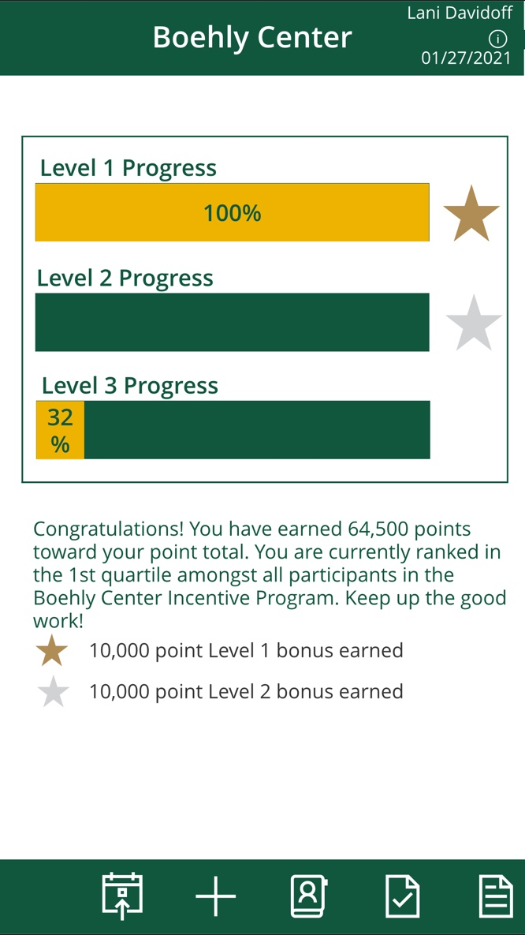
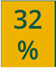
Track your progress throughout the levels here:

View your point total and see where you are in relation to your peers!

Receive 10,000 bonus points for each level that you complete!

